**DR. Robert Antony A**

**Educational Qualifications**

* Ph.D in Microbiology from Bharathidasan University, Tiruchirappalli, Tamilnadu under the guidance of Dr. V. Rajesh Kannan
* Master’s Degree in Microbiology from University of Calicut
* Bachelor’s Degree in Microbiology from University of Calicut

**Achievements**

* **CSIR -JRF - All India Rank 125th**
* **ICAR – NET**
* **ICMR – JRF**
* **GATE**

**Teaching Experience**

* **6** Monthsof teaching experience

### Academic Credentials

* Published **5** research articles and **3** book chapters (International and National)
* Presented and participated in **13** international and National conferences
* Participated in **15** workshop, symposium, and orientation programmes
* **10** bacterialgenomes weresequenced and submitted to NCBI

### Non Academic Credentials

* Life Time member in **Indian Microbiologist Association**
* Won several awards in arts related competition at University, College and School level

Assistant Professor

Department of Microbiology

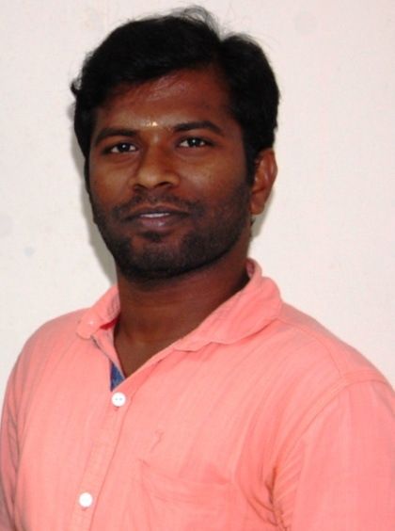

Ph: +91 8344147637

e-mail: robertmicrobiology@gmail.com

**Areas of Specialization**

Rhizosphere Engineering

Food and Agricultural Microbiology

Industrial Microbiology

Environmental Microbiology