**Nimi Narayanan**

**Educational Qualifications**

* **Master’s Degree in Microbiology** from Mahatma Gandhi University, Kottayam
* **Bachelor’s Degree in Zoology** from Mahatma Gandhi University, Kottayam

**Achievements**

Qualified **CSIR JRF** Examiantion

Qualified **ICAR NET**

Training certificate on “ Laboratory Techniques in Food Microbiology” from CIFT, Kochi.

**Teaching Experience**

**7** Yearsof teaching experience as Asistant professor at Govt. Arts and Science College Kozhinjamapara, Palakkad

**1** year teaching experience as Assistant professor on contract in the post graduation department of Sree Sankara College, Kalady, Ernakulam

Member in Board of studies, Microbiology , University of Calicut.

Member in Ad hoc committee of PG syllabus revision, Kannur University.

Chairperson, Board of examiner, MSc. Microbiology Examinations (2022–23)

Member in the panel of UG and PG Examiners in Calicut university.

Principal investigator of Student Project scheme, financially assisted by KSCSTE (2021 -22).

Question paper setter for different universities.

### Other responsibilities

Parents Teachers Association Secretary (2016 – 2018).

Coordinator of GASCK Film Club, 2017 - 2018

Member of Counselling cell, 2017

Member of PTA executive committee, 2019.

Department co-ordinator , YIP , 2019

Member of building committee, (2019 – 2021)

Department co-ordinator, CUSSP (2019 – 2023).

Nature Club co-ordinator , (2019 – 2023).

College co-ordinator, ORICE (2021onwards).

Department co-ordinator, NAAC (2021 – 2023)

Admission Nodal Officer, 2023.

Internal mentor, Scholar Support Programme (SSP) and Walk With Scholar (WWS) (2016 – 2018).

Guide to research projects at post graduation and graduation level.

Assistant Professor

Department of Microbiology

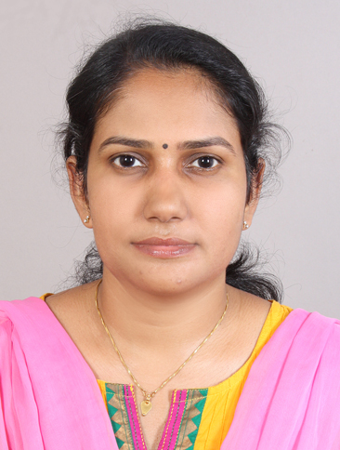

Contact number: **+91 9249570187**

E-mail: [niminarayan@gmail.com](mailto:niminarayan@gmail.com)

**Areas of Specialization**

* Microbial metabolism
* Environmental microbiology
* Anaerobic microbiology
* Biodegradation

LINK TO CV