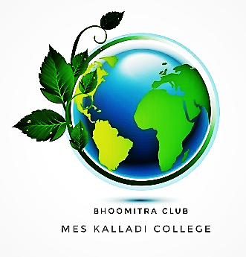
Government Arts and Science College Kozhinjampara

BMC
GASCK
BHOOMITRASENA CLUB
Activity Report: 2023-2024
WORLD ENVIRONMENT DAY -TREE SAPLING DISTRIBUTION (02/06/2023)
In commemoration of World Environment Day, the "Plant a Tree Challenge" was organized by the Bhoomitrasena Club in collaboration with the Nature Club and NSS of GASCK. As part of this initiative, different varieties of tree saplings were distributed to GASCK students on 02/06/2023 by the principal (Dr. Amala and teachers.
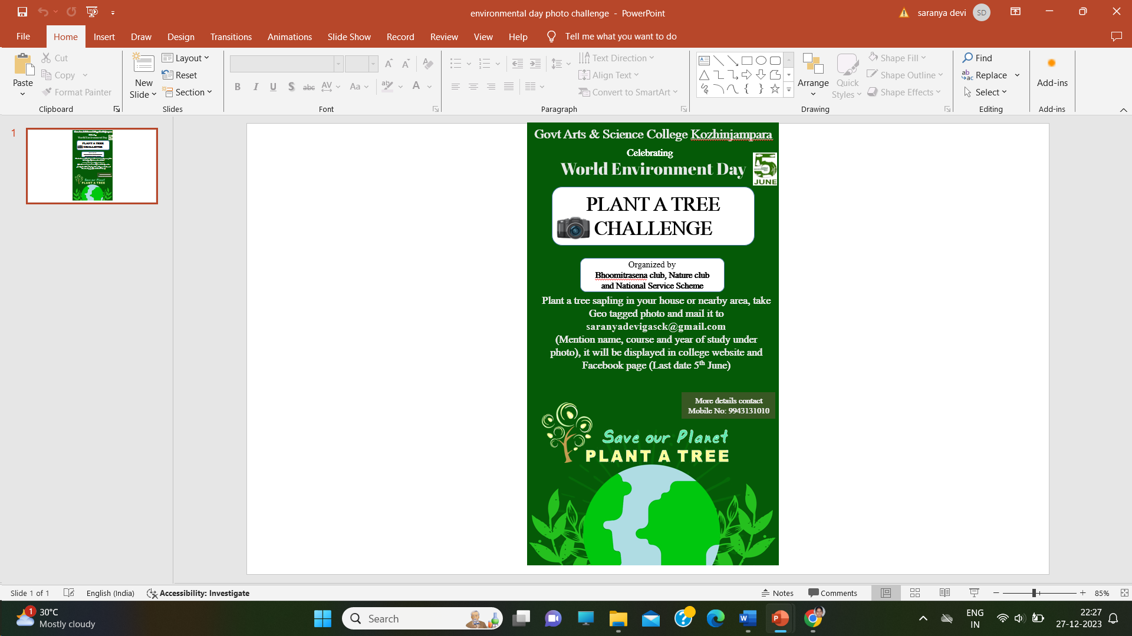
As part of the World Environment Day celebrations, tree saplings were distributed to students to promote environmental awareness and sustainability.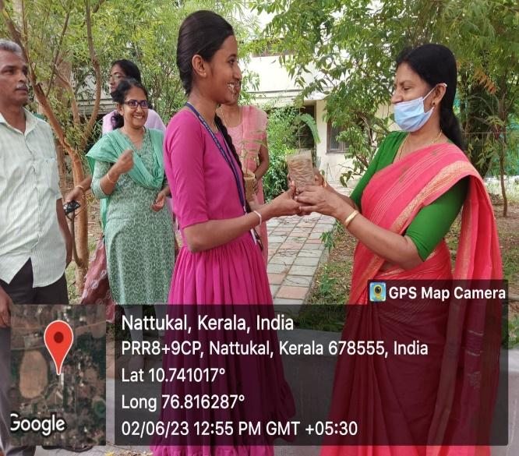

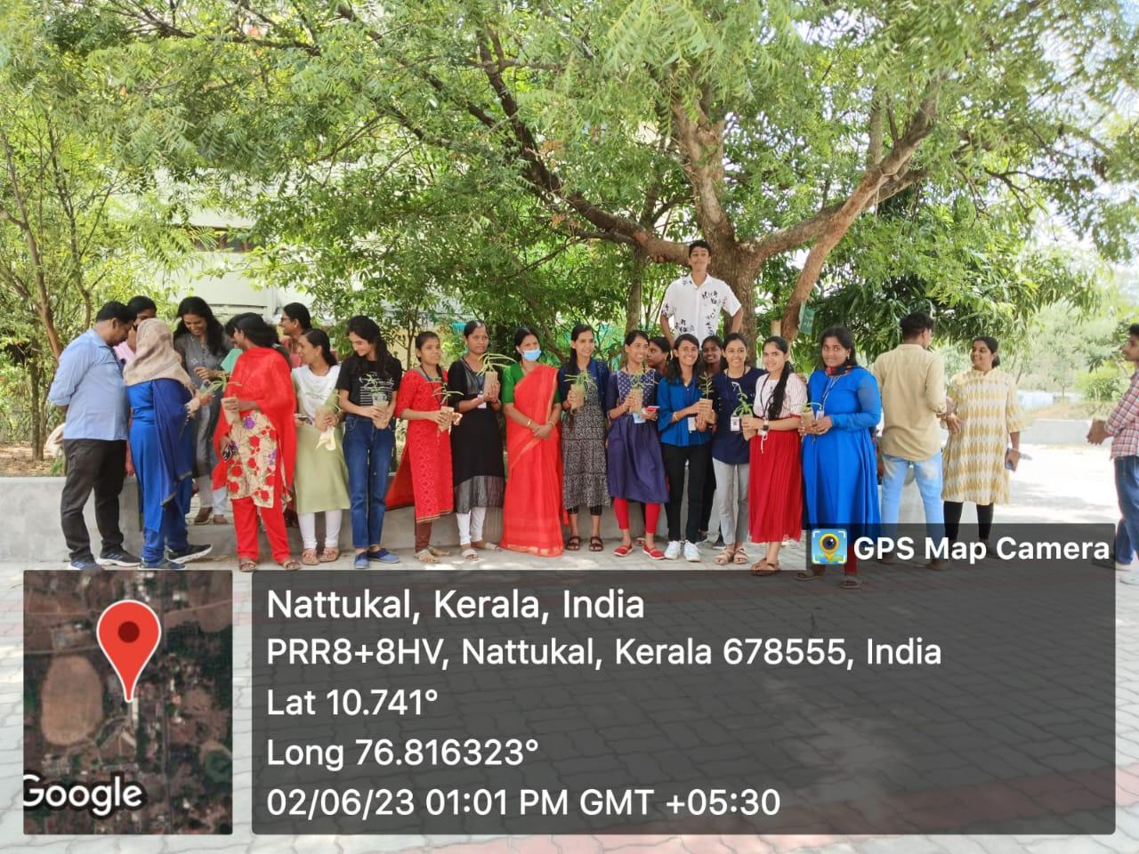

WORLD ENVIRONMENTAL DAY CELEBRATION-
INVITED TALK (05/06/2023)
Dr. Uma J Vinod, Senior Scientist and Head of the Environment Division at IRTC, Palakkad, delivered a talk on the occasion of World Environment Day. The topic of the talk was 'Beat Plastic Pollution,' aiming to redirect focus towards solutions for plastic pollution and instil the significance of reducing, reusing, and recycling plastic among students and staffs.

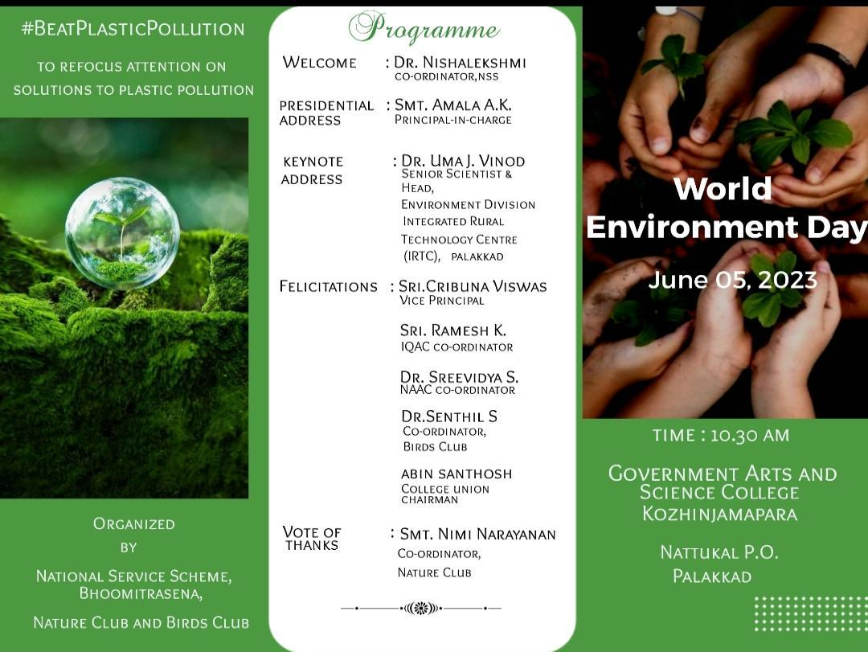
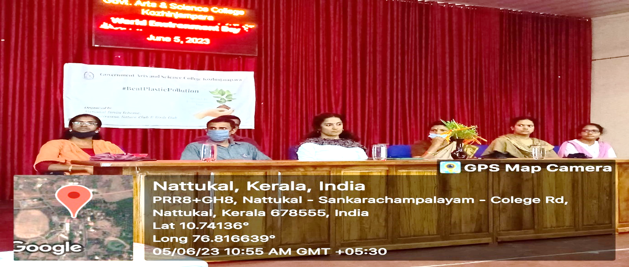
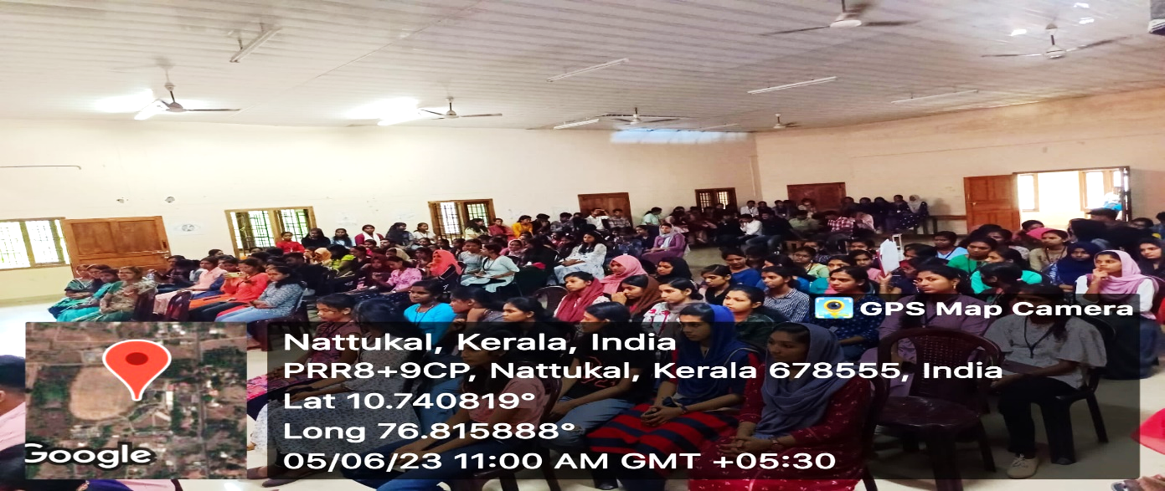

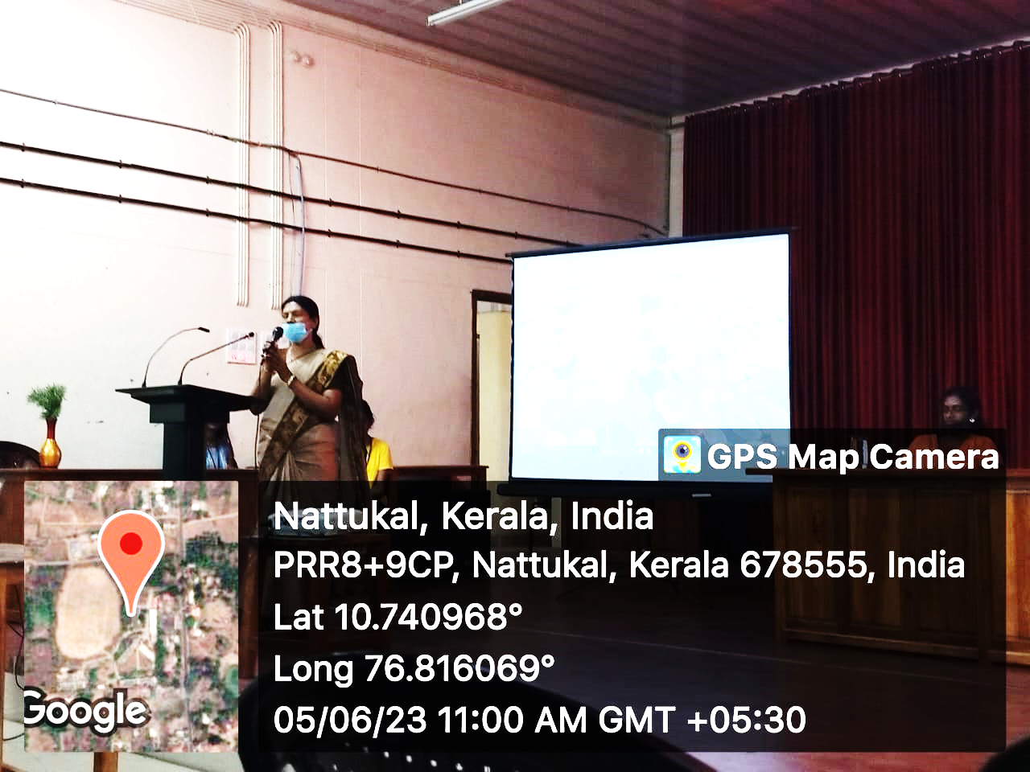
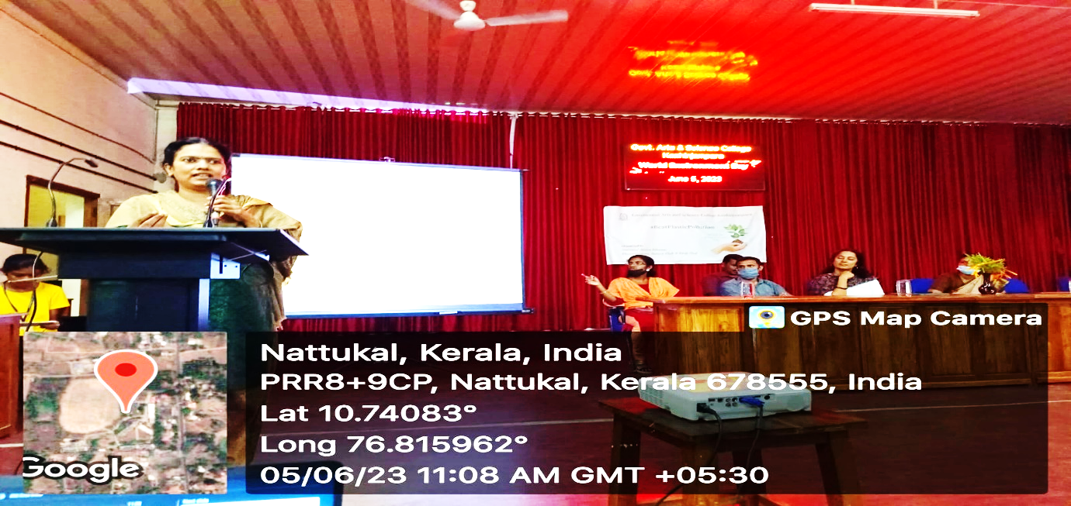
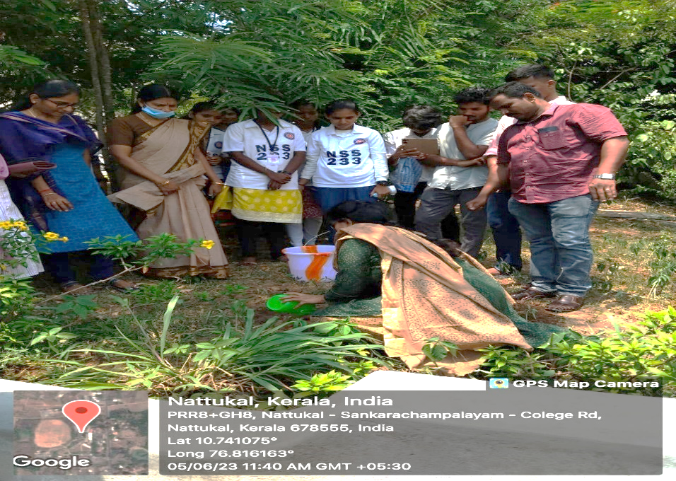
Tree sapling planted by Dr. Uma. J. Vinod (Scientist, IRTC, Palakkad)

HARITHA KALALAYAM INAUGURATION (23/08/2023)
The "Haritha Kalalayam" program was collaboratively organized by GASCK, Nallepilly Gram Panchayath, and Nava Kerala Mission Palakkad. The program commenced with the inauguration of Panchathuruthu (green space) led by Mrs. Sujatha A, President of the Chittur Block Panchayath, and Mrs. Aneesha S, President of the Nallepilly Grama Panchayath. Mr. Saithalavi P, Coordinator of Nava Kerala Mission Palakkad, provided the introduction, while the welcome address was delivered by Mrs. Amala A.K., Principal of GASCK. The felicitation segment was given by the Chairpersons of the Standing Committee of Nallepilly Grama Panchayath, ward member, P.S Easa, (Chairman Aaranyam nature foundation), IQAC and NAAC coordinators.
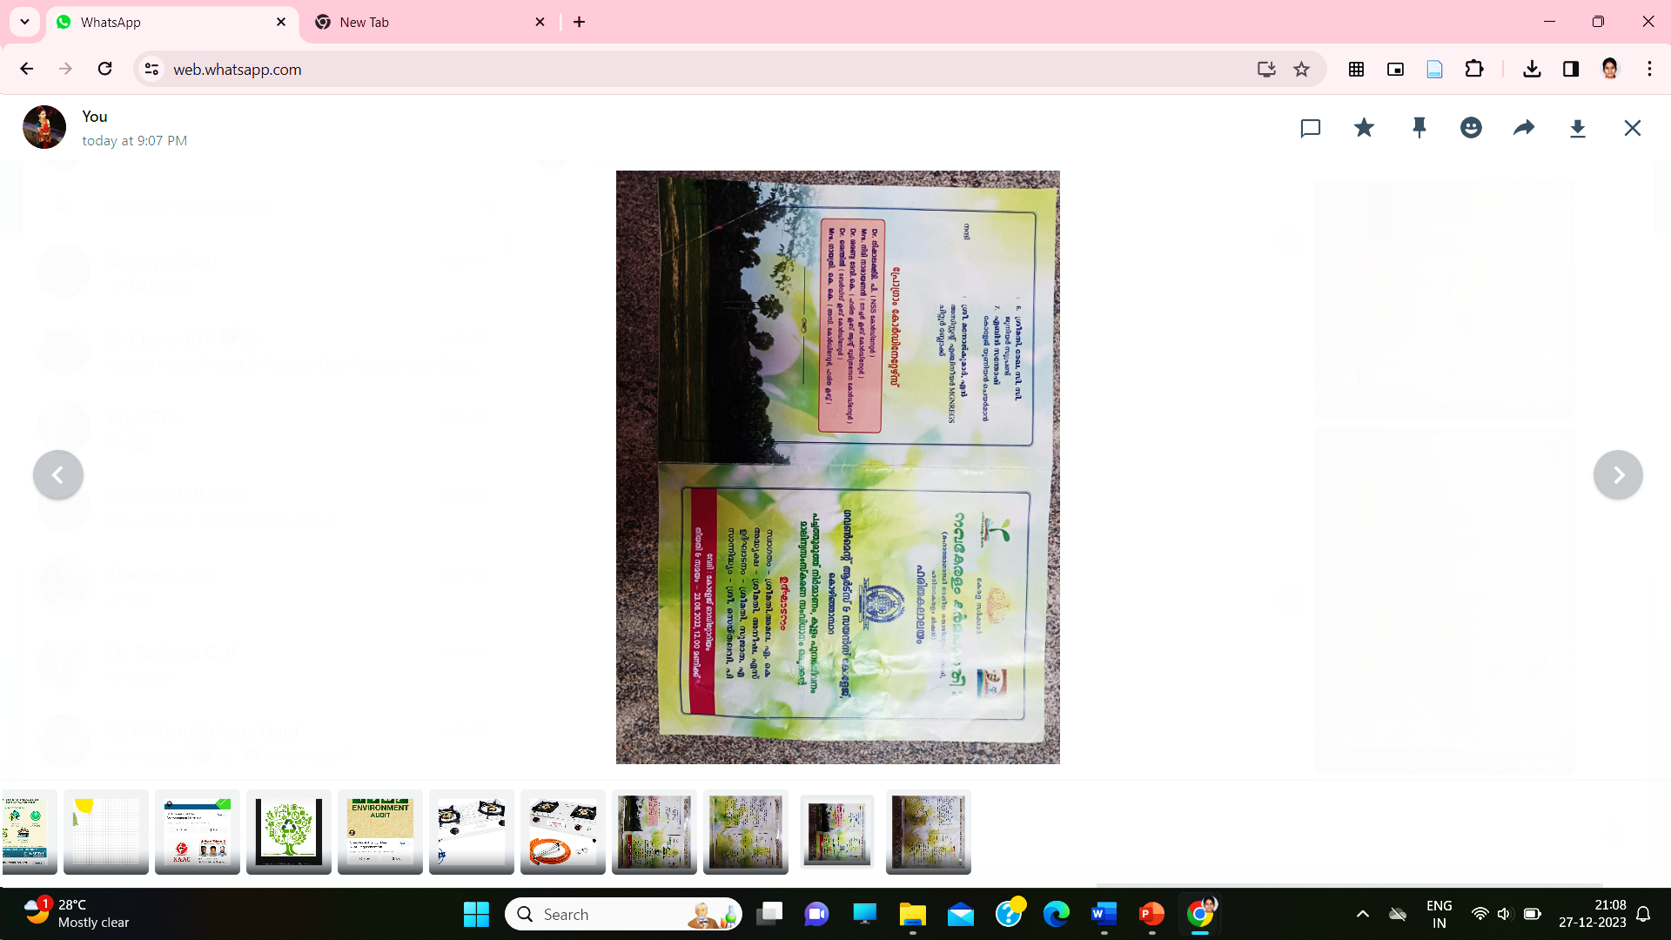
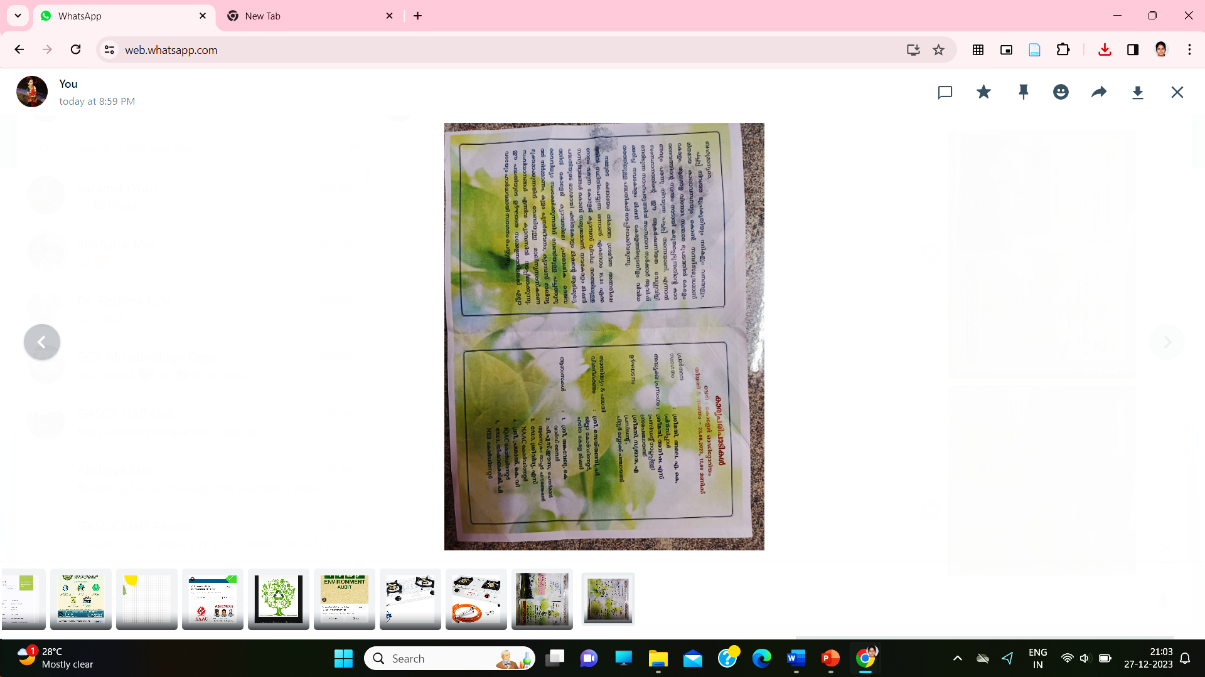

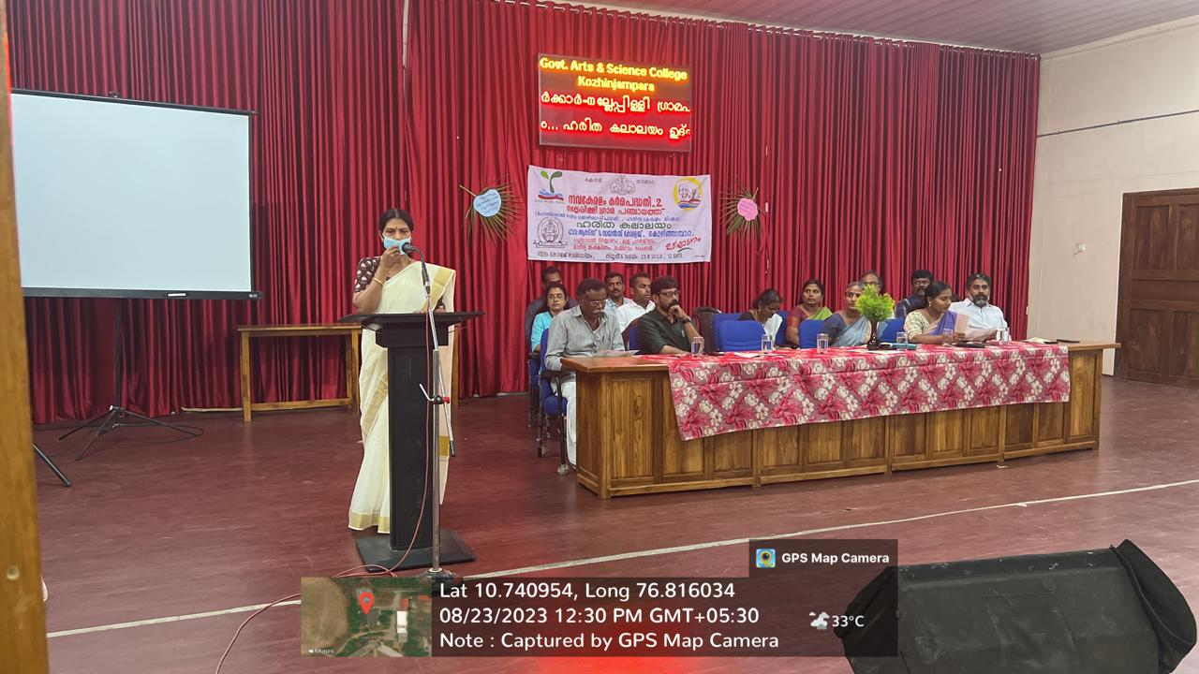
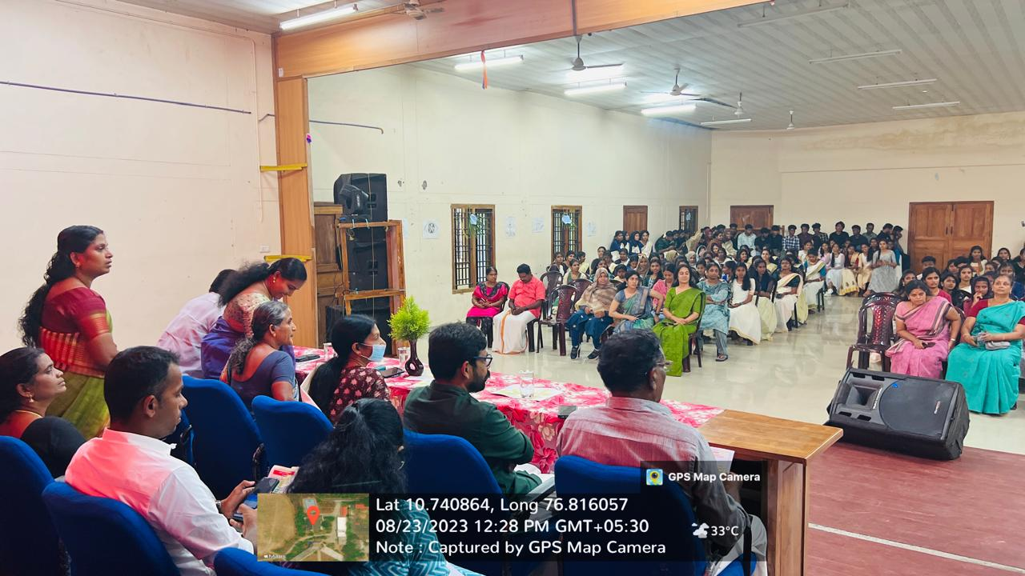

CELEBRATION OF WORLD SOIL DAY (05/12/2023)
In honor of 'World Soil Day,' an awareness campaign was organized by the Green Campus, Bhoomitrasena, and NSS volunteers for undergraduate (UG) and postgraduate (PG) students at GASCK. On that day, additional waste bins were distributed to classrooms, incorporating a color-coded system (green for paper waste and orange for plastic waste), facilitating the segregation of waste materials.
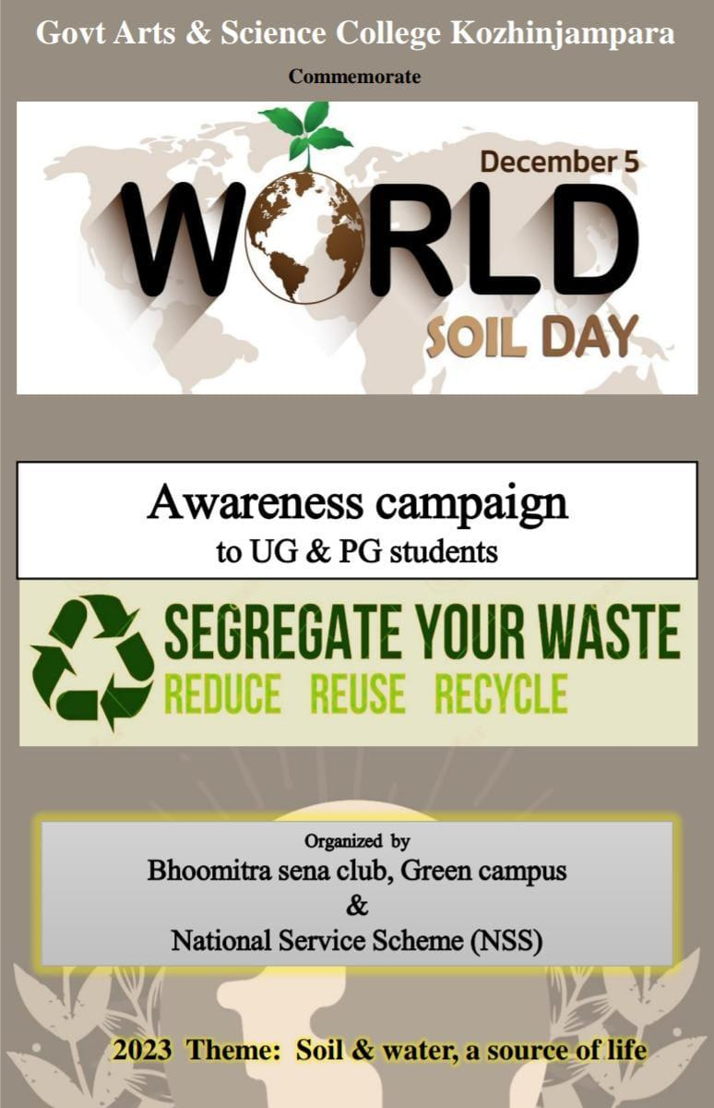

The World Soil Day meeting witnessed active participation from the Bhoomitrasena Club, Green Campus, and NSS volunteers. Dr. Baby, the Principal of GASCK, delivered a compelling talk emphasizing the significance of soil preservation and the need for segregating waste, particularly plastic and paper materials.
During the event, Dr. Baby distributed waste bins to student volunteers, symbolizing the collective effort towards waste management. Student coordinators took the initiative to raise awareness among all classes about the proper segregation of waste through an informative campaign. In this way, the event not only served as a platform for understanding the importance of soil preservation but also took practical steps towards promoting responsible waste management within the campus community.

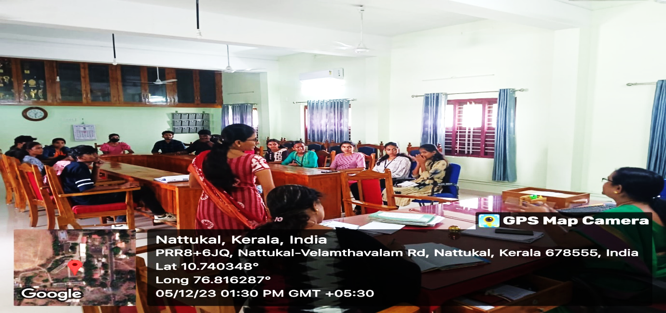
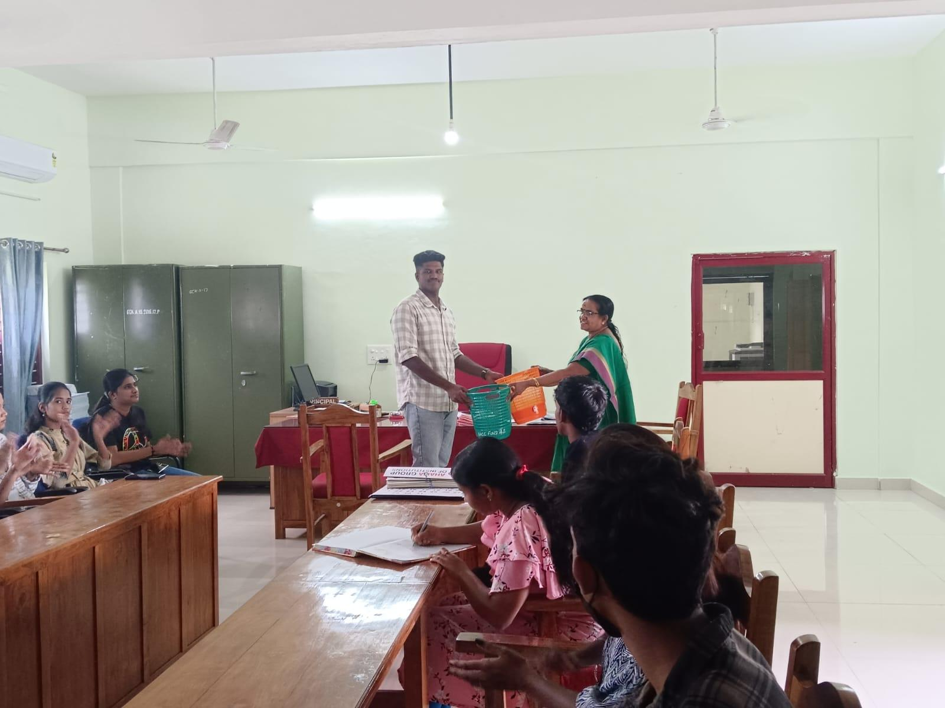
Report Prepared by: Bhoomitrasena club staff Co-ordinator
Dr. Saranya Devi K
Assistant Professor
Department of Microbiology
Government Arts and Science College Kozhinjampara

