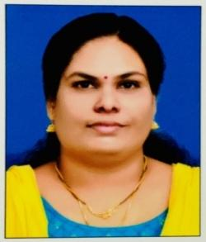

**Faculty Profile**

Name of the faculty : DEEPA MOHAN

Designation : Assistant Professor

Date of entry into regular service : 27.06.2019

1. Service history

| Sl. No | Name of University/ College | From | To |
| --- | --- | --- | --- |
| 1. | Government Arts & Science College, Kozhinjampara | 27.06.2019 | 07.09.2020 |
| 2. | Government College, Ambalapuzha | 08.09.2020 | 02.08.2024 |
| 3. | Government Arts & Science College, Tholanur | 07.08.2024 | 22.08.2024 |
| 4. | Government Arts & Science College, Kozhinjampara | 23.08.2024 | Present |

2. Educational qualifications

| Sl. No | Degree | Year of Passing | University |
| --- | --- | --- | --- |
| 1. | BA | 2004 | University of Kerala |
| 2. | BEd | 2010 | University of Kerala |
| 3. | MA | 2006 | University of Kerala |
| 4. | UGC-NET | 2010 |  |