JIJI.R

Educational Qualifications
- M.A. Economics from Govt. College, Chittur. (University of Calicut).
- B.A. Economics from Govt. College, Chittur. (University of Calicut).

Achievements
- UGC NET.

Teaching Experience
- Assistant professor on Contract in Economics in the UG Department of Economics at MPMM SN Trust College SHORANUR(2015-16, 2016-17,2018-19)
- Assistant professor on Contract in Economics in the UG Department of Tamil,Govt.Arts and Science College Kozhinjampara (June 2023 -october 2023)
- Assistant professor on Contract in Economics in the UG Department of Economics at NSS College Nenmara (2025-26)
- Assistant professor on Contract in Economics in the UG Department of Tamil ( from 12/6/2026 to till)

Academic activities other than teaching
- Member of Hunger Free Campus Program committee.

Assistant Professor on Contract – Economics
Department of Tamil

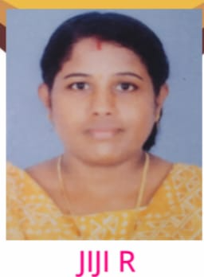

Ph: 9744430038
E-mail: jijijkrishnan2015@gmail.com

Areas of Specialization
Welfare Economics
Gender economics

.

