Shijila K.
Assistant Professor,
Department of English
Ph: 9061780204
Email: shijilakvdzy@gmail.com
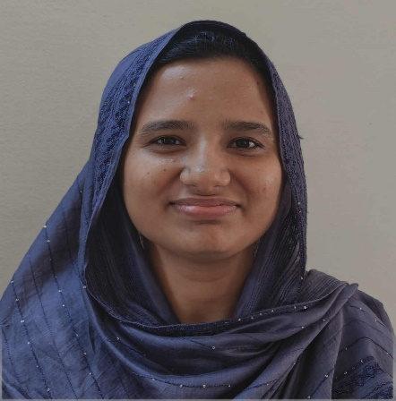

Areas of interest:
- Palestinian Literature
- Historiographic Metafiction
- Science Poetry
- Indian English Literature
- Translation Studies
- Phonetics
Educational Qualifications:
- Ph. D (English), University of Calicut, March 2022
- M. A. English Language and Literature, Govt. Victoria College, Palakkad, July 2015
- B. A. English Language and Literature, Mercy College, Palakkad, March 2013
Achievements:
- Qualified UGC-JRF, December 2014
- Qualified UGC-NET, June 2014
Teaching Experience:
- Assistant Professor of English, Govt. Arts and Science College, Kozhinjampara (March 2026 onwards)
- Attended centralized UG valuation camps (University of Calicut).
- Exam question paper setter (University of Calicut).

